New Kitten Cheat Sheet

Food
Kitten may not eat for first day or even two, or you will not see him/her eating. Most likely kitten will eat when you are sleeping and don’t see him. You can check the litter box to be sure if she/he is eating and drinking. If you don't see kitten drinking water for more then 2 days and her/his litter box is empty, please consider taking him/her to the vet. Kitten might not eat little longer, probably day or two.
Please, do not change kitten diet at first two month.
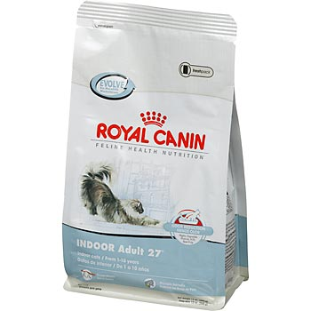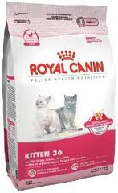
We are feeding our cats and kittens Royal Canin Kitten 36 (4-12 month) and Royal Canin Indoor Adult 27. Please, consider buying this food at least for the two first weeks and maybe for longer. You can continue to use Royal Canin Kitten, and then later Indoor. You may change kitten’s diet slowly, give the kitten new food in a small amounts every day until he get regular to it.

It is very important to maintain good diet for a cat. Actually it is the most important thing in cat health. Please, buy only premium dry food. If you not sure about specific brand you can contact the cattery for advice. Please do not buy any food at general supermarkets like King Soopers, Wal-Mart, Target etc., they don't carry premium brands. Check you closest pet specializing store, PetSmart or PetCO carry some of the good food brands.
We almost never giving kittens canned food; it is not a good source of nutrition for the kittens. You can give it as a snack.
Here the list of foods you could give to the kitten or cat together with dry food: rare beef meet, cooked chicken without bones, rare eggs yellows, 5% half and half, canned tuna in water. Cats might like other strange things, you can always try. They most likely will not like fruits, vegetables, pork and other fatty meet. They might like milk and cooked seafood, maybe bacon or pastrami. Fish is not good food for cats.
Some kittens not like anything except dry food and it is OK to feed the cat only dry food.
We never limit cat on food, cat should always have access to the water and dry food.
Good Dry food brand marks existing in the market:
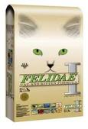

Litter Box and Litter
You will need litter box
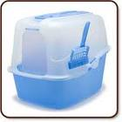
Litter that we use (we use green one even for multiple cats):
This one is also we used and some cats like it.
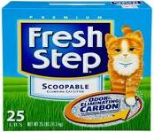
Kitten generally should be ok to use any litter, but some cats like specific types better than others. Some kittens also will like covered litter box better but without doors.

Toys, Nail Clipper and Scratch Pad
Your kitten will need scratch pad (also he will like catnip)
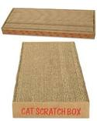
Nail Clipepr (look for a small one, it is good even for adult cats)
Brush (this one works best for British Shorthair)

Of course toys
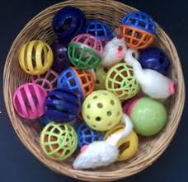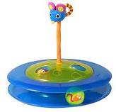

Vitamins and Supplements
I am buying vitamins only online. I didn’t find any good vitamins and supplements in nearby pet stores.
http://www.onlynaturalpet.com/
This one they actually like and eating by themselves (that is very rare) …
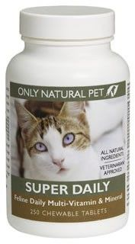
http://www.onlynaturalpet.com/products/Only-Natural-Pet-Super-Daily-Feline-Vitamins/999011.aspx
This brand has some other special supplements, and you can try. This store also has some homeopathic medicine that also may help in case of problems.
http://www.revivalanimal.com/
We are using those, adding it to the kittens and cats meal and dry food every day. We are adding it to dry food and also to canned food for the kittens.
Daily Care:
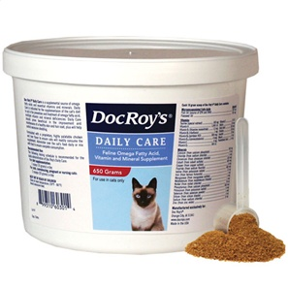
http://www.revivalanimal.com/store/i/is.aspx?path=/shared/images/products/60301-904.jpg&lr=t&bw=520&bh=520
Absorb More:
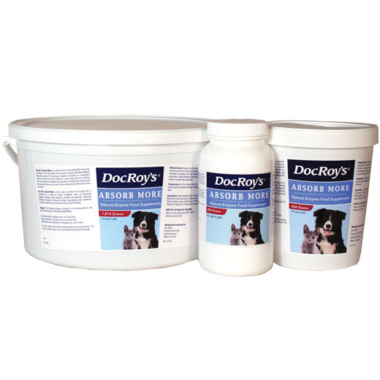
http://www.revivalanimal.com/Doc-Roys-Absorb-More.html
Forti-Cal:
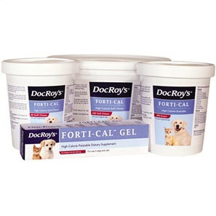
http://www.revivalanimal.com/Doc-Roys-Forti-Cal.html

Socialization
The socialization period for kittens is between three and seven weeks of age. Kittens are exposed to as many different influences as possible during this time. This socialization period will be while the kitten is still with its mother and litter mates.
You will need to carry on with socialization.
The banket rule:
When you bring home your new kitten, sit on the floor quietly and place a fleece blanket on your lap and encourage kitty to come to you or when the kitten is sleepy place him/her on your lap, never do this when the kitten is playing as you will not have their full attention and they will get stressed trying to get away from you to play. Keep doing this until your kitten comes to you to sleep on your lap on his/her own accord. Use the sofa tip below once you have got this.
This is a tip from experience so please do it. To encourage your bond with your new kitten place a blanket on the sofa and use this as kittens bed, this will encourage kitten to be near to you and not shy of you & your visitors, also have a special fleece that you place on your lap, only use the special blanket when you have it on you and put it away when you are not. Always stoke kitten softly then allow sleeping peacefully. Do not use the blanket as a time to start playing as kitten will get cross if he is sleepy and wont thank you for the attention. This tip has proved to be the best thing i have ever done and my bond with my cats has become very strong. It takes days/weeks depending on the kitten

Kitten Proofing
Young kittens like to climb and explore. Make sure you do a safety check of your house to see what dangers your kitten may find.
Washing machines/tumble dryers/ovens etc… - please check kitten is not curled up in clothes and keep doors shut on kitchen appliances
Air fresheners like sprays, plug-ins etc.
Keep toilet seats down (all the time)
Windows shut - buy screens to have them open
Never use body sprays in same room with kitten
Cat toys with string
Household plants that may be poisonous
Knives, scissors, pins
Cleaning rags or sponges
Hanging cords on curtains or blinds
Electrical cords the kitten may chew
Medicines
Small objects the kitten could swallow
Cleaning products such as detergent or bleach
Antifreeze, oil, brake fluid, weed killer etc…
Think of your kitten as a newborn baby and you won’t go far wrong!

Medicine and kitten care
Once again, we prefer to buy it online. If kitten/cat has a serious problem, it is always a good to get him to a vet. You will see when kitten not feeling well, but sometimes you will not realize that something going wrong until late. The main indication that something is going wrong is that kitten changes his behavior, or start doing things that you did not see it before. For example, if you start to see him less playing and more time sleeping. Very important to see and check if he has diarrhea or other problems with stool, so it is always good idea to check it regularly. The obvious things as diarrhea you will see very fast, but some signs may not be so obvious. Also if kittens are throwing up often is the sign to see the doctor, but if it happens only once a while you may not worry so much. Cat able not to eat for some time, but must drink. If you see kitten not drinking for more than 1-2 days, you should get it to the vet. Kitten conditions can develop much faster than in adult cats and get worse much faster too. Of course the doctor should prescribe most of medicines, but there is out some very good medicaments that can help and which not need prescription. Of course you should read carefully the uses of every medicament and see if it really will help in your specific case.
Here I want to mention couple that may be used in case you see certain symptoms but think that they not very critical to take kitten to the vet.
Sometime cat can have some eye discharge, which is not uncommon, but usually will not be permanent. It may depend on environment, condition and kitten immune system. Usually you can clean it with clean napkin and water. If you see that discharge is permanent and not normal and/or the eye is reddish it is good idea to show cat to the doctor.
In case of diarrhea: Stop to give any other food then dry food. Give only Royal Canin Kitten or Indoor or any other brands you used before. You can give Pumpkin paste (that one that used for pies). You can also give rare beef meet (not processed, cut to pieces). You can give probiotics. If diarrhea continued after you giving all that and persists for more then 3-4 days – consider taking him to a vet.
Cleaning ears: you can clean it from time to time.
Cleaning eyes: if you see discharge, with clean napkin and water of eyes care products for cats.

L-Lysine
Conditions can be used: fewer sneezing fits, runny eyes, and stuffy nose, breathing noise
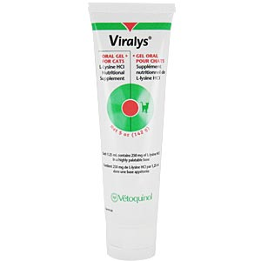
http://www.vetdepot.com/viralys-l-lysine-gel-5-oz.html
Terramycin
Conditions can be used: any kind of eye discharge, eye redness.
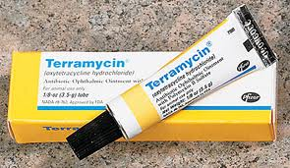

Probios
Conditions can be used: not firmed stool, diarrhea
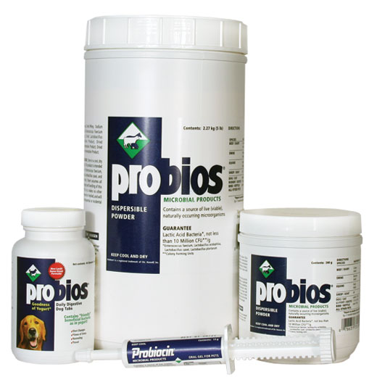

Diarsanyl
Conditions can be used: not firmed stool, diarrhea
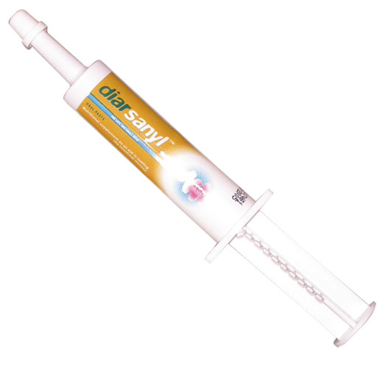

PetAg® Bene-Bac® Plus Pet Gel & Powder
Conditions can be used: not firmed stool, diarrhea
